Virtusa React Training

B Sahil (221910304005)

Day 1 - 24/11/2022

1. Installation of VScode
2. Installation of NPM (Node Package Manager)

Source - [Download | Node.js (nodejs.org)](https://nodejs.org/en/download/)

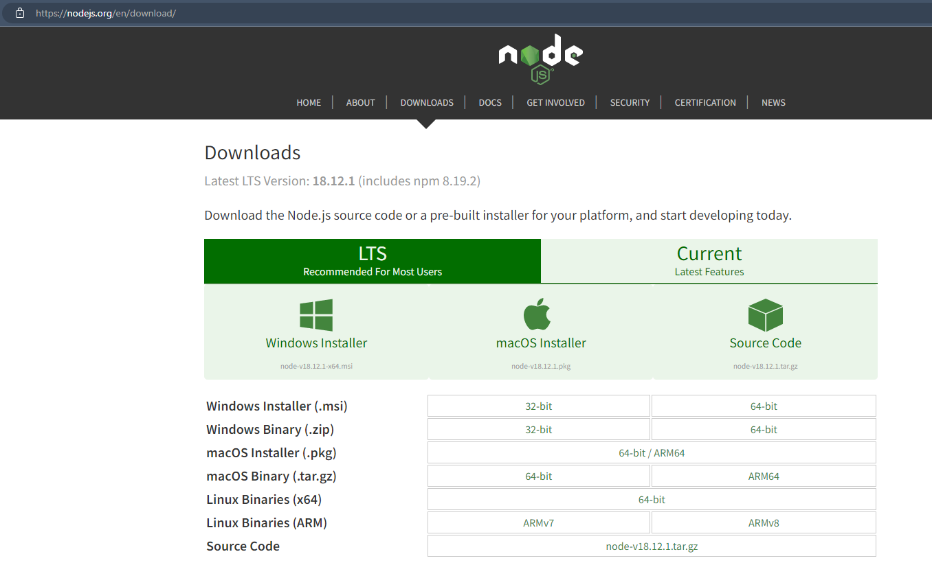

Check the Version in the command prompt, use command “npm-v”.



1. Now to create a react application, npm should contain prerequisites for it. So, to install ‘npm install create-react-app’ is the command to be noted and executed.

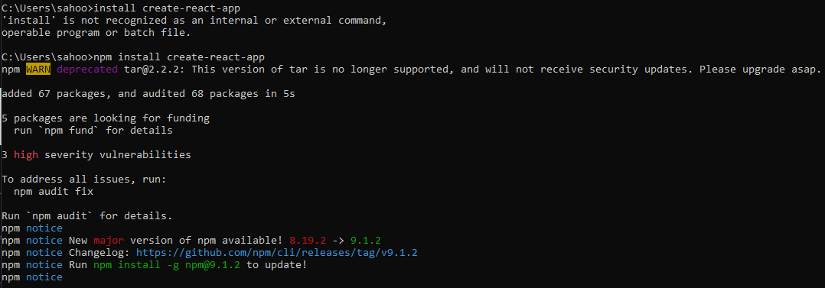

NPM Audit Report -

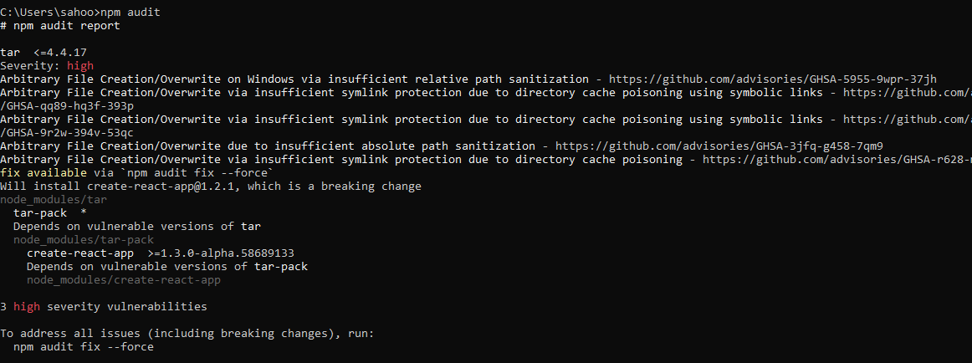

1. Create a folder to save all the react projects.

Here “React_4005” is the folder name.

1. Create a react project using command “npx create-react-app firstproj”.

Here “firstproj” is the name of the project.

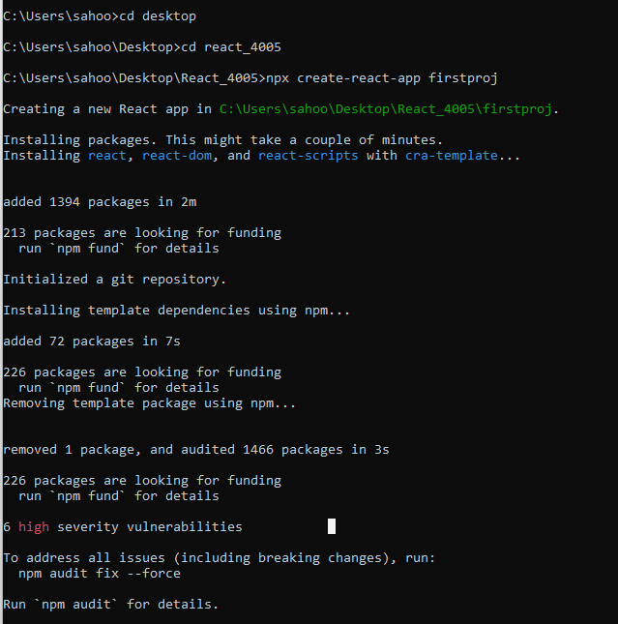

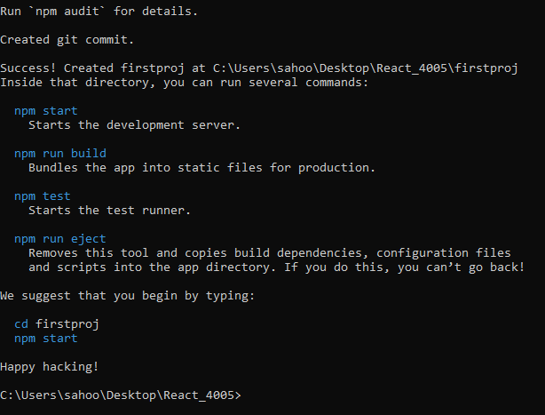

1. Start the project using the command “npm start”.

(Redirect to the project directory “firstproj “and execute the above command)

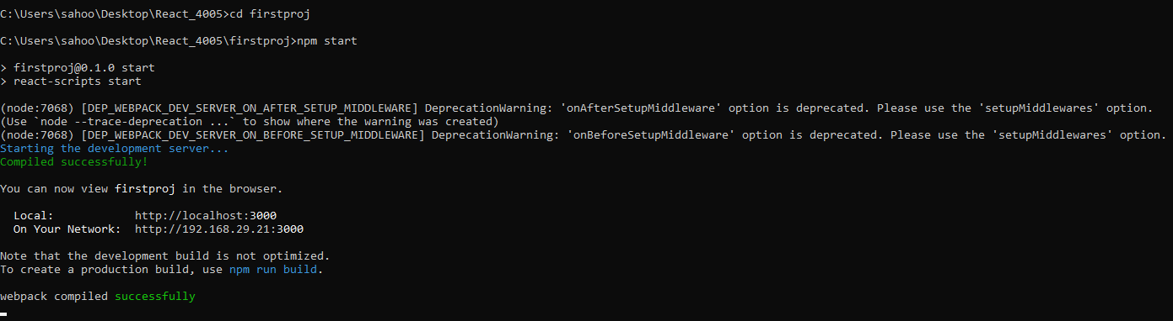

Verify the localhost port number as 3000

